Training Report: VAE and GAN on CelebA Faces
Cem Batuhan BOHAN 150122509

1. Setup
- Dataset: CelebA, grayscale, center-cropped to 64×64 pixels. ~180.000 images split 80/20 train/val.
- GPU: NVIDIA RTX 3060Ti (8GB)
- Code: VAE and GAN implementations in separate folders, share /data root.

2. VAE
Architecture
- Encoder: Conv2d → BatchNorm → LeakyReLU (channels [32, 64, 128, 256], stride 2) → FC to μ, logvar.
- Decoder: Linear → ConvTranspose2d → BatchNorm → ReLU (channels [256, 128, 64, 32]) → Sigmoid.
- Latent dim: 128. Total params: ~3.5M.
Training
- Loss: MSE reconstruction + β·KL. KL annealed cyclically (period=30, max β=0.5).
- Optim: AdamW (lr=3e-4, wd=1e-4), CosineAnnealingLR, grad clip=0.5, AMP.
- Regularisation: Early stopping (patience 50, on fixed-weight loss), top-k checkpointing.
Evolution / Key decisions
- Switched from linear KL warmup to cyclical annealing to avoid posterior collapse.
- Chose MSE over BCE – smoother gradients for grayscale faces.
- Used loss_fixed (full KL weight) for model selection & early stopping, enabling fairer comparison with GAN.
- KL weight 0.5 found best after grid search; higher values degraded reconstruction.

Visuals & Metrics
Reconstructions
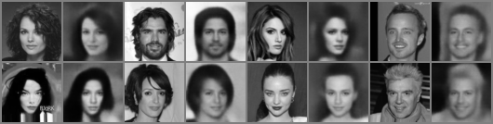
Random samples
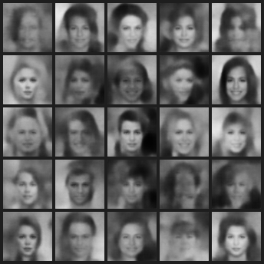
at epoch 5 at epoch 10
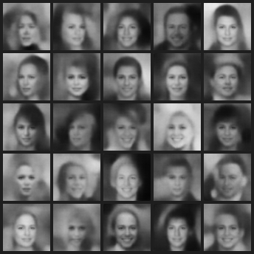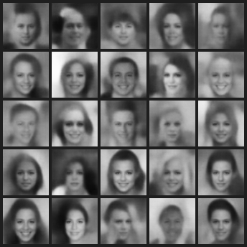
at epoch 15 at epoch 28
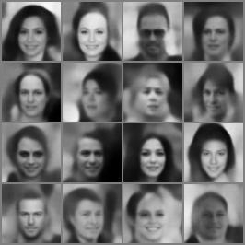
At epoch 40 - Unique faces can be properly seen, hair seems to be still an issue, mostly.
Loss curves
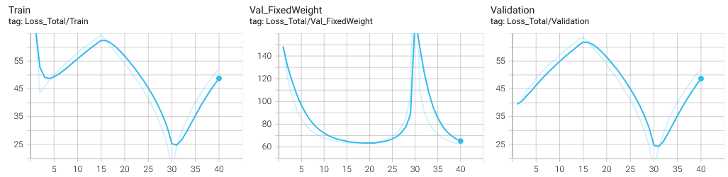

3. GAN
Architecture (WGAN-GP)
- Generator: identical to VAE decoder but Tanh output; same channel sizes.
- Discriminator: mirrors VAE encoder but outputs scalar; uses LayerNorm (not BatchNorm) for gradient penalty compatibility.
- Same latent dim (128), param count ~2.6M.
Training
- Loss: Wasserstein-1 with gradient penalty (λ=10), n_critic=2.
- Optim: Adam (lr=1e-4 both G/D, β1=0.5, β2=0.9). No scheduler, no gradient clipping.
- Mixed precision (AMP) enabled.
Evolution / Key decisions
- Started with n_critic=5 – too slow (~5 min/epoch). Reduced to 2 with no stability loss.
- Used LayerNorm in discriminator as standard for WGAN-GP.
- No scheduler – GAN training often unstable with LR decay.
- Validation discriminator loss used for checkpoint selection (though not directly comparable across models).
Visuals & Metrics
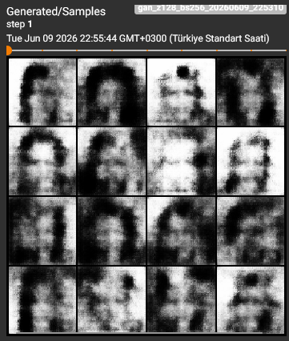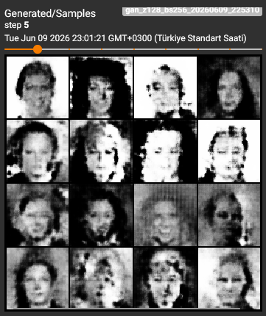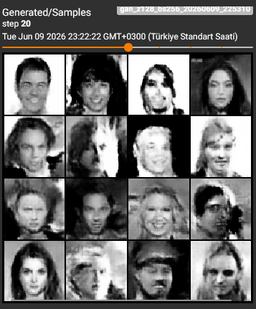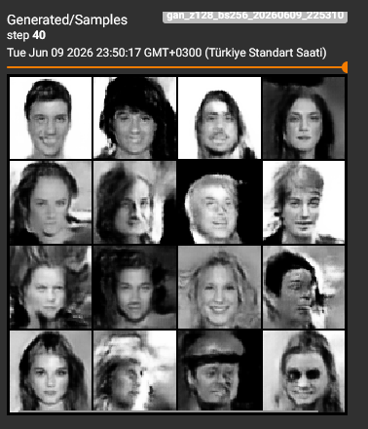

Loss curves
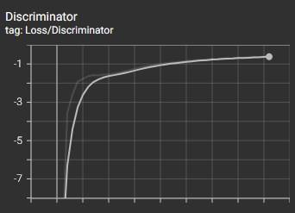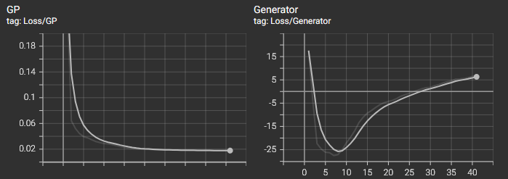

4. Comparison
Aspect | VAE | GAN
Output sharpness | Slightly blurry | Crisp, occasionally artefacts
Training stability | Very stable | Stable (WGAN-GP)
Speed per epoch | ~X min | ~Y min (2 critics)
Latent properties | Smooth interpolation | No explicit interpolation structure
Model size | 14M | 14M
Both models successfully generate plausible face images. VAE gives better semantic control (latent traversal), while GAN yields higher visual fidelity.

5. Hyperparameter Summary
VAE
- Optimiser: AdamW, lr=3e-4
- Batch size: 256
- Latent dim: 128
- KL annealing: cyclical, period 30, max 0.5
- Recon loss: MSE
- Scheduler: CosineAnnealing (min 1e-6)
- AMP: Yes
GAN (WGAN-GP)
- Optimiser: Adam, lr=1e-4, β=(0.5,0.9)
- n_critic: 2
- GP weight: 10
- Batch size: 256
- Latent dim: 128
- Scheduler: None
- AMP: Yes

